Kubernetes Task-9
- Execute all the steps shown in video.
- Upgrade k8s cluster from 1.26 to 1.28 Version. Note: Document to upgrade cluster. https://devopscube.com/upgrade-kubernetes-cluster-kubeadm/
1 vi deployment.yml
apiVersion: apps/v1
kind: Deployment
metadata:
name: nginx-deployment
spec:
replicas: 1
selector:
matchLabels:
app: nginx
template:
metadata:
labels:
app: nginx
spec:
containers:
- name: nginx
image: nginx:latest
ports:
- containerPort: 80

Kubectl create -f deployment.yml
Kubectl get pods
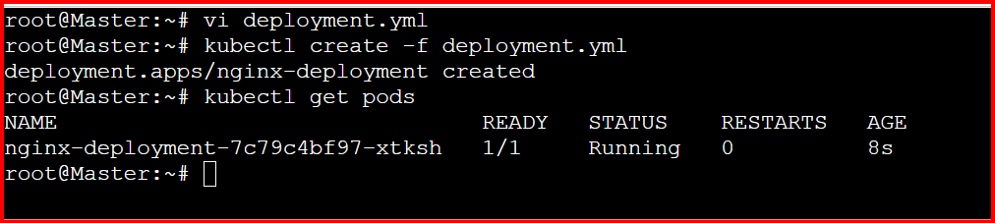

Service.yml
===========
apiVersion: v1
kind: Service
metadata:
name: nginx-service
spec:
selector:
app: nginx
ports:
- protocol: TCP
port: 80
targetPort: 80
nodePort: 30001
type: NodePort
kubectl apply -f service.yml
kubectl get services
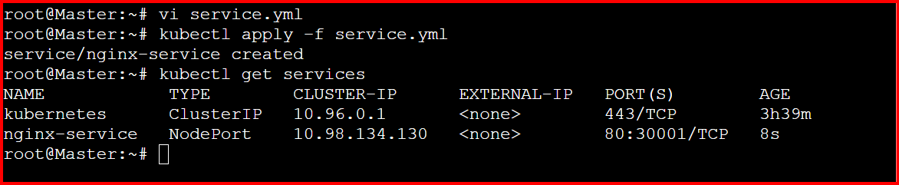

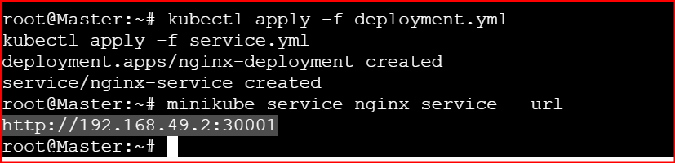
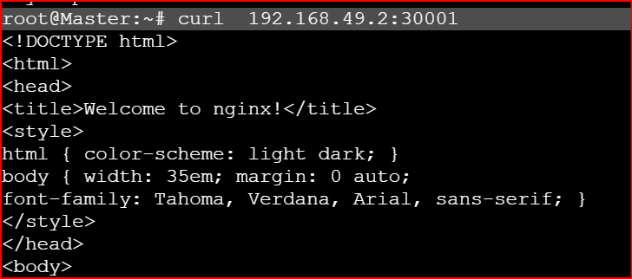
Ingress.yml
===========
apiVersion: networking.k8s.io/v1
kind: Ingress
metadata:
name: nginx-ingress
spec:
rules:
- host: example.com
http:
paths:
- path: /
pathType: Prefix
backend:
service:
name: nginx-service
port:
number: 80

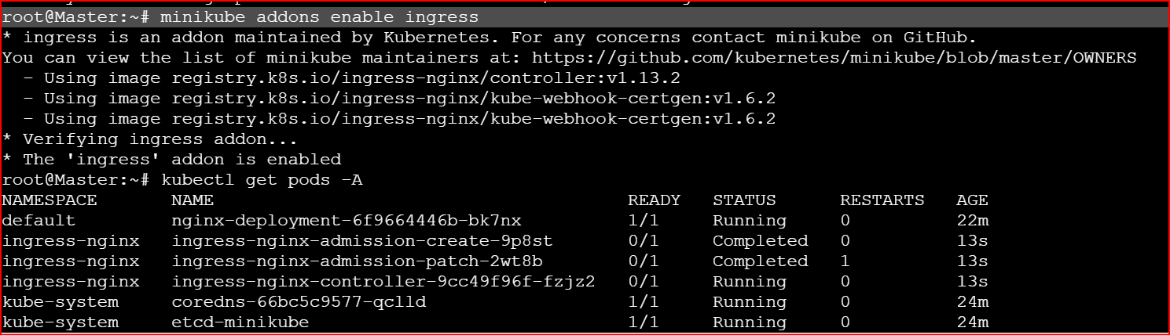
Kubectl get ingress
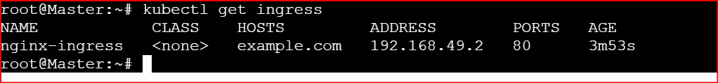

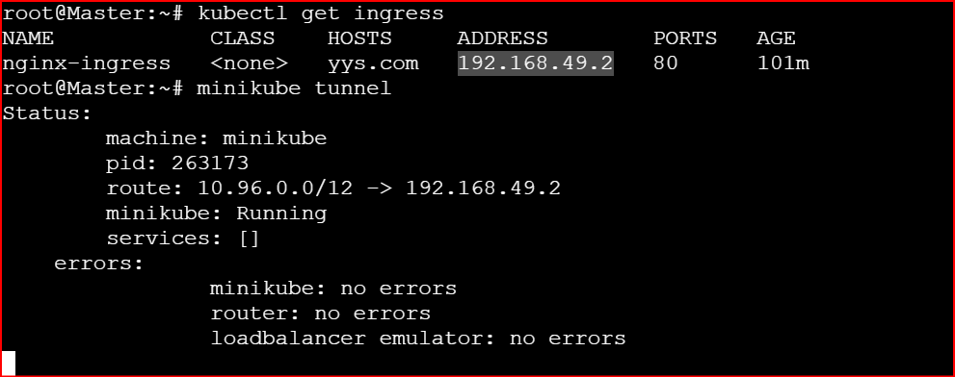
Check the versions
Of kubectl kubelet
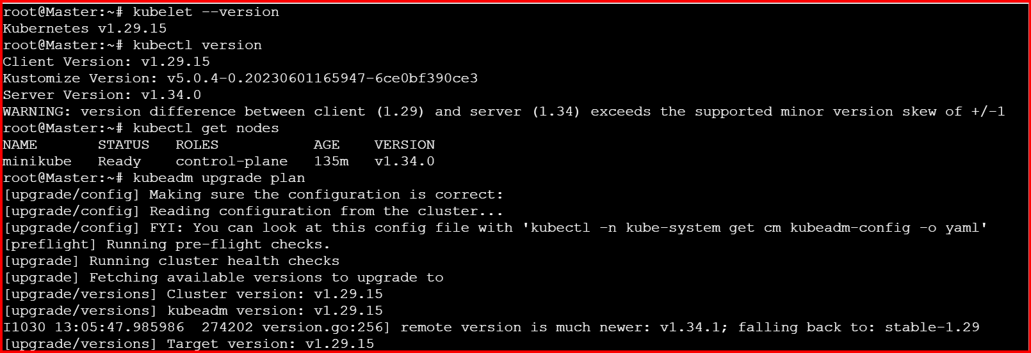

apt update
apt-cache madison kubeadm | tac
This command lists all available versions of the kubeadm package from your configured repositories.

